Share your edible gardens and inspire new green creations! Tell us about your tricks and discoveries that have made your home productive and ecological!

Participate in the Rooftop Garden Project’s
Balconies in Bloom Contest!

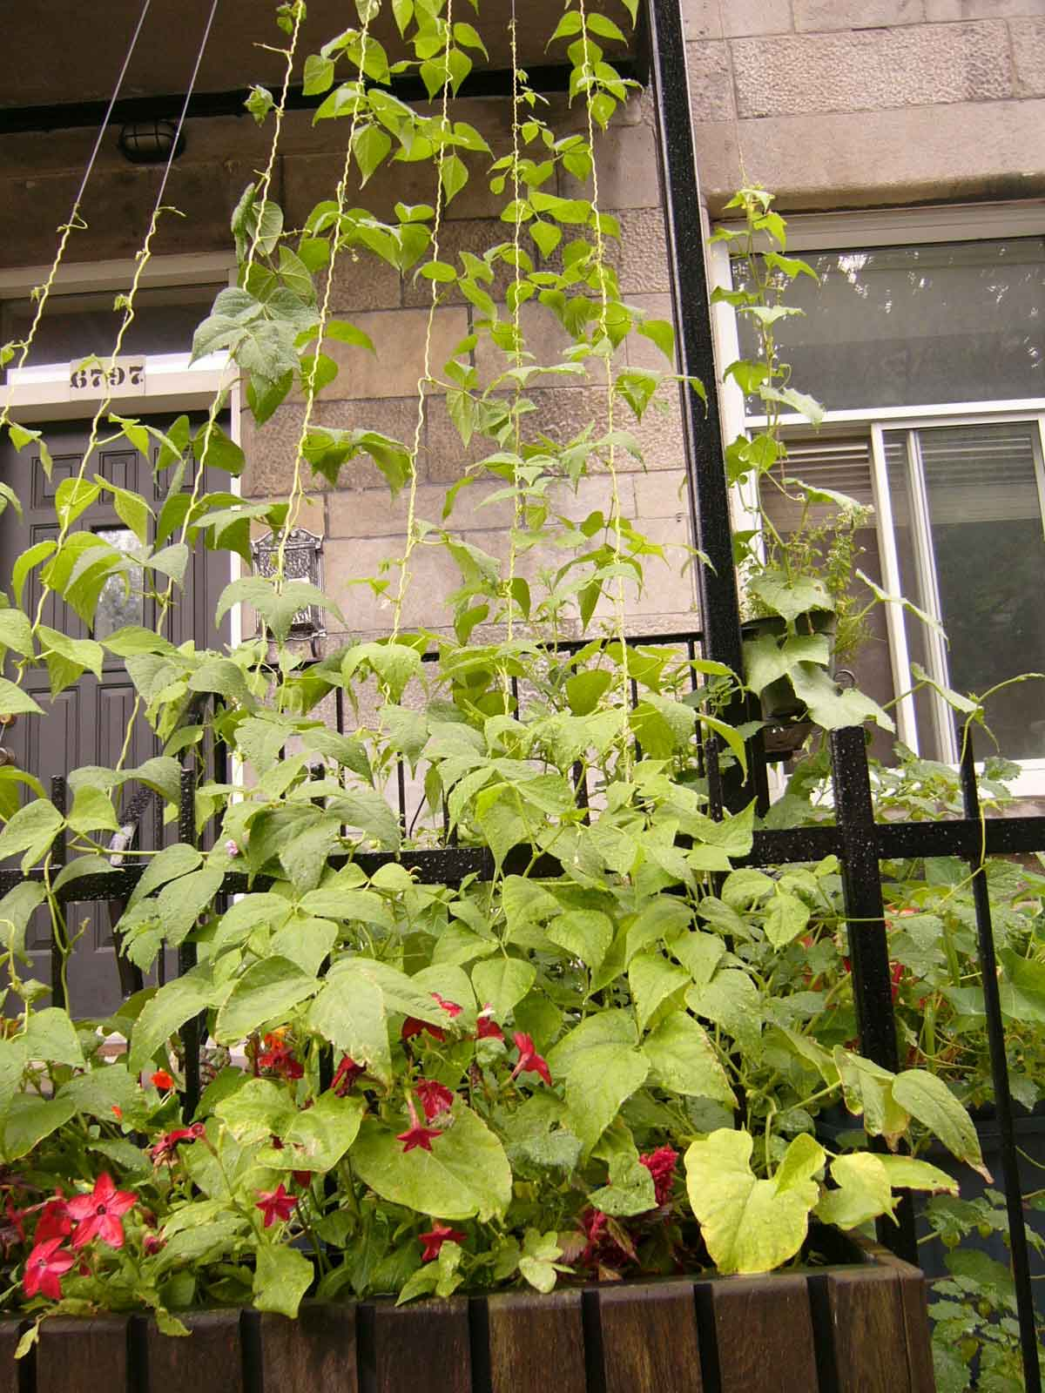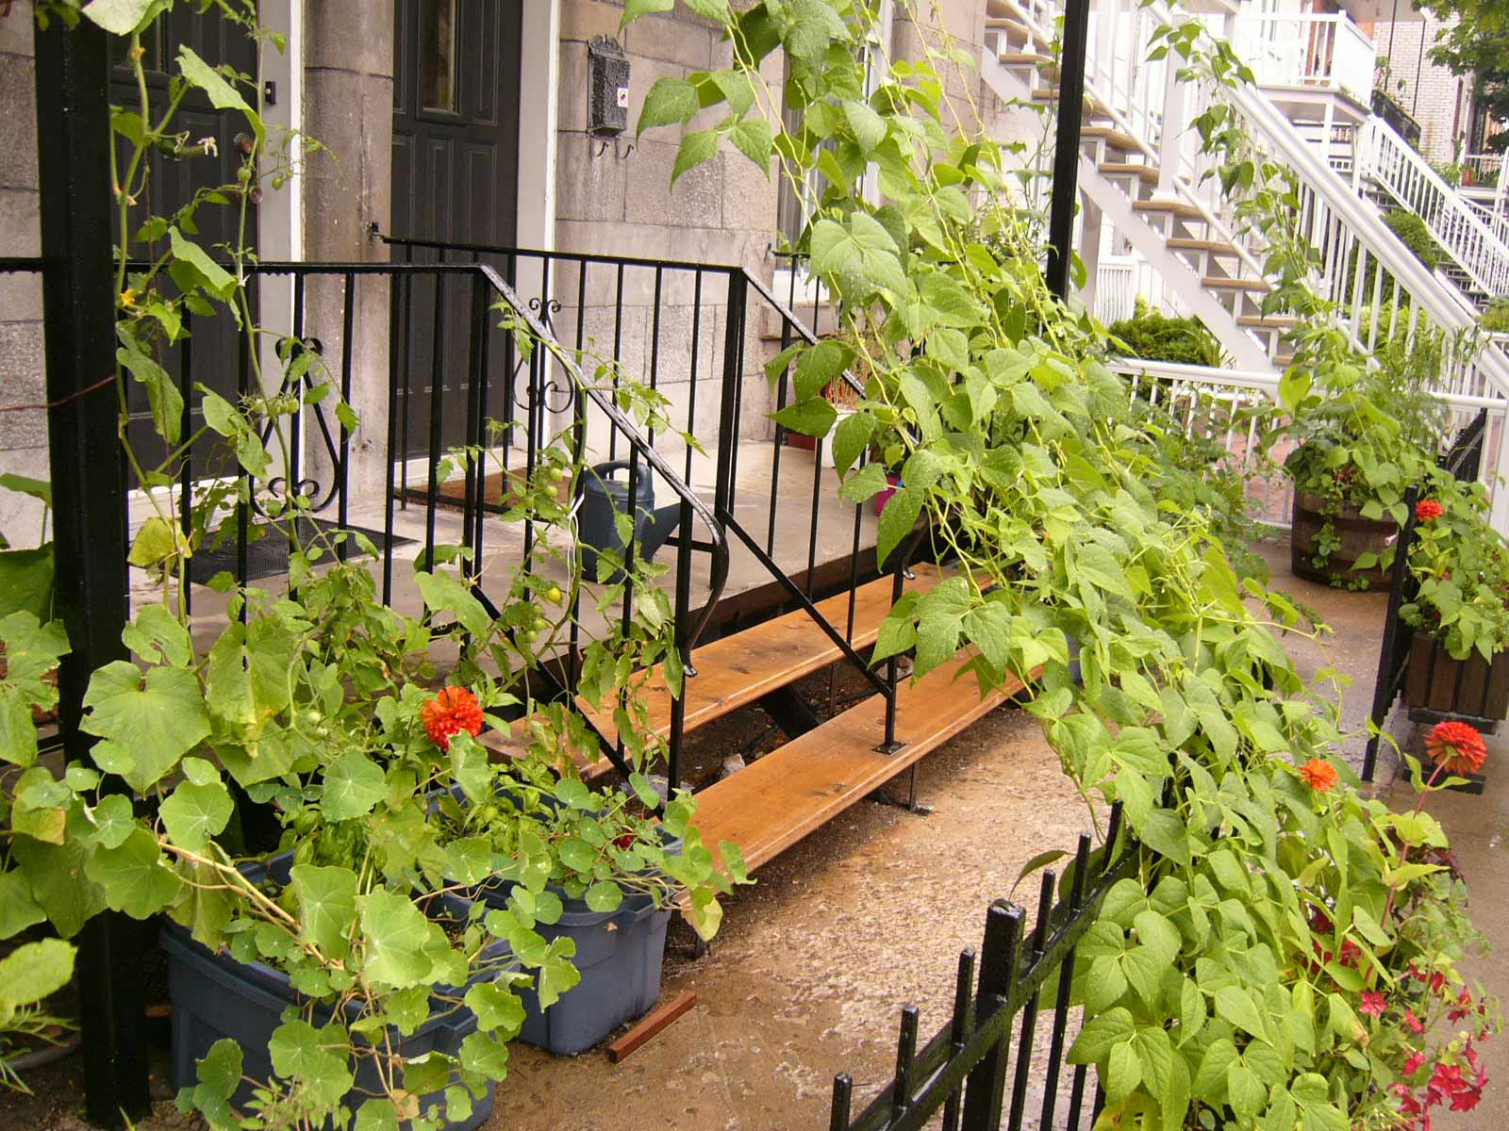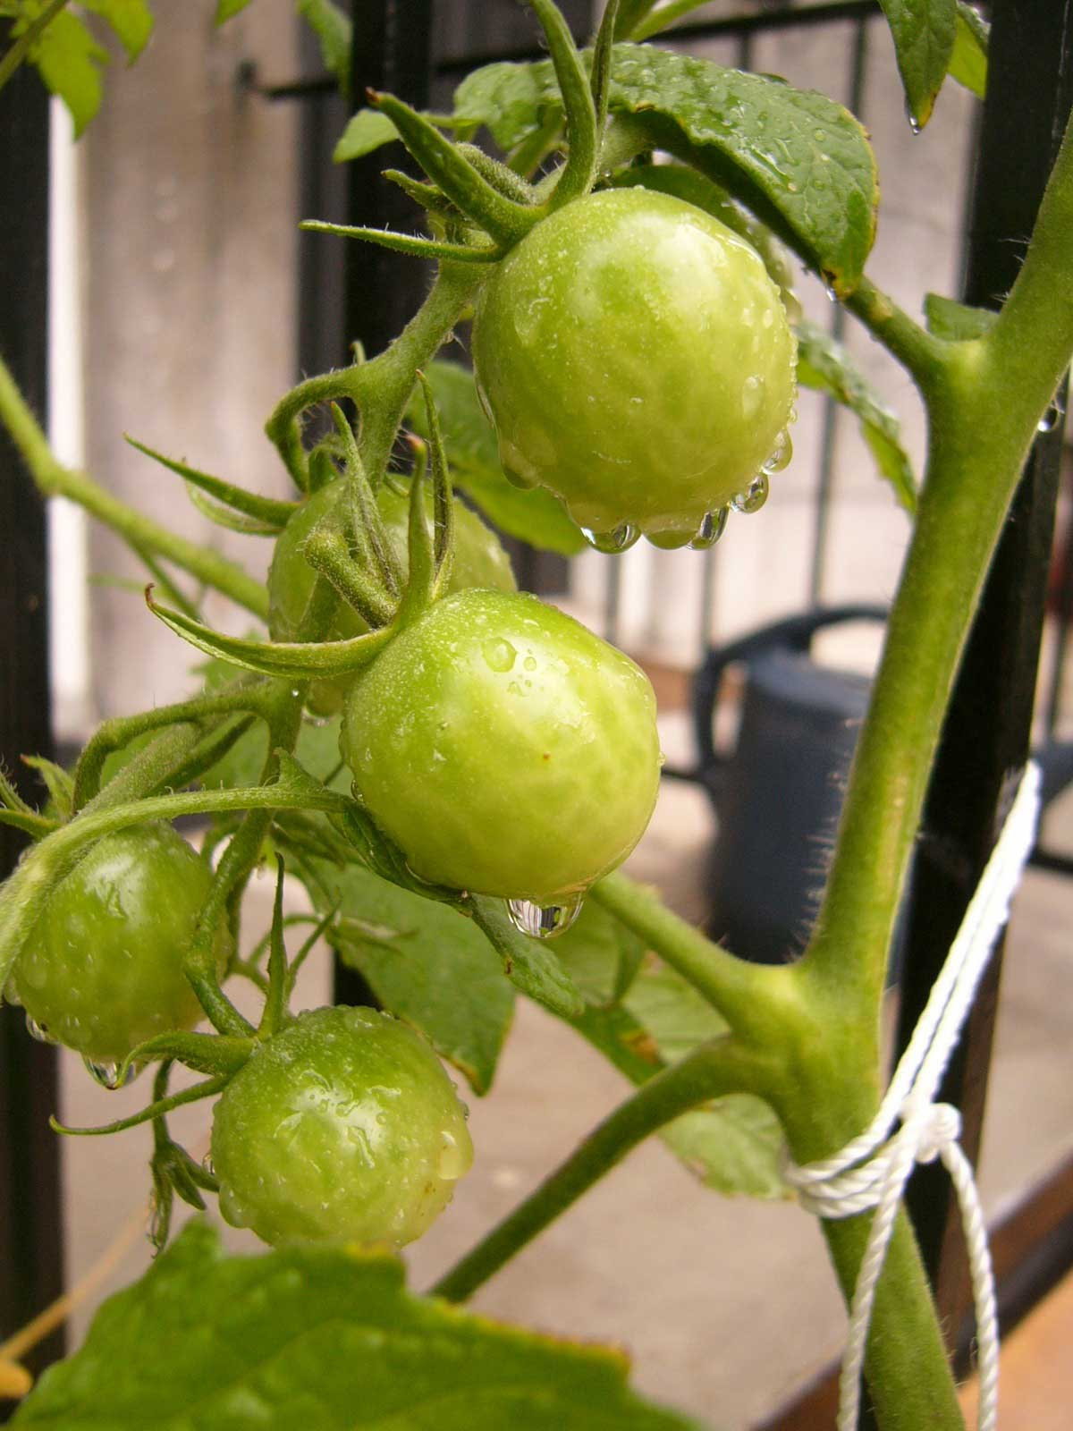

The Rooftop Garden Project invites you to share how your environmentally respectful behaviours can go hand-in-hand with pleasure, discovery, beauty and taste.

To participate in the contest, please send us the following items before September 1st 2007:
- 3 photos of your blooming balcony (or container garden)
- A brief description of your garden and what inspires you
- The completed application form
The gardens will be displayed anonymously on our website : www.rooftopgardens.ca and in the garden during our Harvest Festival in September. Winners will be chosen by the public on-site according to the following criteria:

- Beauty
- Originality
- Functionality
- Ecological and technical features
- Social aspects (sharing of space, harvest, knowledge, etc…)

Prizes will be awarded during the Harvest Festival!

For more information or to submit your application, contact:

Ismael Hautecoeur / tel 514-982-6606 x 2230 / mail: ismael@alternatives.ca

Happy gardening!
Application Form for Balconies in Bloom 2007
Name:
Phone number:
Neighbourhood:
Number of containers used:
Container type:
Plant varieties used:
Star fruit or vegetable:
Who consumes the harvest?:
Number of people involved:
Type of soil used:
Type of fertilisers used:
If you are using an Alternatives self-watering container-
How often do you water?
Is the user’s guide helpful?
Problems encountered:
Other comments:
Advice for other gardeners:

